**DESIGN AND IMPLEMENTATION OF RESTAURANT TABLE RESERVATION SYSTEM WITH ONLINE PAYMENT**

**(A case study of NAZA Restaurant, Mubi)**

# TITLE PAGE

**BY**

**LA'AZARUS SANDRA**

**(ST/CS/ND/23/147)**

**USMAN SAAD BODEJO**

**(ST/CS/ND/23/193)**

**DEPARTMENT OF COMPUTER SCIENCE,**

**SCHOOL OF SCIENCE AND TECHNOLOGY,**

**FEDERAL POLYTECHNIC, MUBI, ADAMAWA STATE.**

**IN PARTIAL FULFILLMENT OF THE REQUIREMENT FOR THE AWARD OF NATIONAL DIPLOMA (ND) IN COMPUTER SCIENCE.**

**JULY, 2025**

# DECLARATION

We hereby declare that the work in this project titled “**Design and Implementation of Restaurant Table Reservation System with Online Payment (A case study of NAZA Restaurant, Mubi)**” was performed by us under the supervision of Mal. Ziyaulhaq Mustafa Hamman.The information derived from literature has been duly acknowledged in the text and a list of references provided. The work embodied in this project is original and has not been submitted in part or in full for any other diploma or certificate of this or any other institution.

La’azarus Sandra ________________ _______________

(ST/CS/ND/23/147) Signature Date

Usman Saad Bodejo ________________ _______________

(ST/CS/ND/23/193) Signature Date

# CERTIFICATION

This project titled “**Design and Implementation of Restaurant Table Reservation System with Online Payment (A case study of NAZA Restaurant, Mubi)**” meets the regulations governing the award of National Diploma (ND) in Computer Science, Federal Polytechnic Mubi, Adamawa State

Mal. Ziyaulhaq Mustafa Hamman __________________

(Project Supervisor) Sign/Date

Mal. Mustapha Kassim. __________________

(Head of Department) Sign/Date

Mal. Abdulrahman Saidu _________________

(External Examiner) Sign/Date

# DEDICATION

This project is dedicated to our beloved parents and love ones for their advice, encouragement and financial support towards our academic pursuit.

# ACKNOWLEDGEMENTS

We acknowledge Almighty God for His infinite mercy and protection throughout our academic journey and for granting us the understanding to achieve academic success.

We also recognize our supervisor, Mal. Ziyaulhaq Mustafa Hamman, who, despite his busy schedule, took the time to guide and direct us throughout this research work.

We extend our gratitude to the Head of the Computer Science Department, Mal. Mustapha Kassim, for his moral encouragement during our period of study. We also acknowledge all the staff of the Computer Science Department for their support, encouragement, and the knowledge they have imparted to us throughout our studies.

We deeply appreciate our lovely parents for their love, care, and for giving us the opportunity to be educated and achieve our dreams.

Finally, we are grateful for the encouragement and support of our uncles, aunties, friends, relatives, course mates, and all well-wishers. We love you all. May Almighty God bless you abundantly. Amen.

# TABLE OF CONTENTS

TITLE PAGE i

DECLARATION ii

CERTIFICATION iii

DEDICATION iv

ACKNOWLEDGEMENTS v

TABLE OF CONTENTS vi

LIST OF FIGURES viii

LIST OF TABLES ix

ABSTRACT x

CHAPTER ONE 1

INTRODUCTION 1

1.1 Background to the Study 1

1.2 Problem Statement 2

1.3 Aim and Objectives 2

1.4 Significance of the Study 2

1.5 Scope of the Study 3

1.6 Definition of Some Operational Terms 3

Chapter TWO 5

Literature Review 5

2.1 Introduction 5

2.2 Related Literature 5

2.3 Evolution of Reservation Systems 6

2.4 Benefits of Digital Reservation Systems 7

2.5 Key Features of Reservation Systems 8

2.6 Information Management System 9

2.6.1 Importance of Information Management Systems 10

2.7 Database Management System 10

CHAPTER THREE 12

SYSTEM ANALYSIS AND DESIGN 12

3.1 Introduction 12

3.2 Disadvantages of the Existing System 12

3.3 Advantages of the Proposed System 12

3.4 Software Development Model 12

3.5 Method of Data Collection 14

3.6 System Design 14

3.6.1 Algorithm Diagram 14

3.6.1 Algorithm diagrams 14

3.6.3 Database Tables/Queries Structures 16

3.6.4 Database Entity Relationship Diagram 18

3.6.6 Input and Output Design 18

3.7 System Requirement Specification 19

3.7.1 Hardware Requirements 19

3.7.2 Software Requirements 19

3.7.3 Personnel Requirement 19

CHAPTER FOUR 20

RESULTS AND DISCUSSION 20

4.1 Introduction 20

4.2 Results 20

4.2.3 Home page interface 21

4.3 Discussion 24

4.4 User manual 26

4.4.1 System Installation 26

4.4.2 System Operational Guide 26

CHAPTER FIVE 27

SUMMARY, CONCLUSION AND RECOMMENDATIONS 27

5.1 Summary 27

5.2 Conclusion 27

5.3 Recommendations 27

REFERENCES 28

APPENDIX A 30

APPENDIX B 33

# LIST OF FIGURES

Figure 3.1: Waterfall model - - - - - - - - 11

Figure 3.2: Use case diagram- - - - - - - - 12

Figure 3.3: System Architecture - - - - - - - - 12

Figure 3.4: Database Entity Relationship Diagram - - - - - - 14

Figure 3.5: Reservation Form - - - - - - - - 15

Figure 3.6: Check Booking Status - - - - - - - - 15

Figure 3.7: Reservation history - - - - - - - - 15

Figure 3.8: Add Table Form - - - - - - - - 16

Figure 3.9: Confirmation of Reservation - - - - - - - 16

Figure 4.1: Registration Interface - - - - - - - - 17

Figure 4.2: Checking Booking Status - - - - - - - 17

Figure 4.3: Make Reservation - - - - - - - - 18

Figure 4.4: Add Table Interface - - - - - - - - 18

Figure 4.5: Booking details - - - - - - - - 19

Figure 4.6: Dashboard interface - - - - - - - - 19

# LIST OF TABLES

Table 1: Booking Table - - - - - - - - - 13

Table 2: Admin Table - - - - - - - - 13

Table 3: Booking Status - - - - - - - - 14

Table 4: Table - - - - - - - - - 14

# ****ABSTRACT****

*In today's rapidly evolving restaurant industry, the demand for efficient and automated reservation systems is increasing due to the limitations of traditional methods such as pen-and-paper or phone bookings. This study aims to design and implement a robust Restaurant Reservation system that leverages modern technology to streamline the reservation process, enhance customer experience, and optimize restaurant operations. The system incorporates key features such as online booking, table management, and notification systems, integrated with a secure database using HTML/CSS, JavaScript, PHP and MySQL. This project not only contributes to the existing body of knowledge by presenting a comprehensive solution to the challenges of manual reservation systems but also sets a precedent for future innovations in the restaurant industry.*

# CHAPTER ONE

# INTRODUCTION

## 1.1 Background to the Study

In today's fast-paced world, the restaurant industry faces the challenge of efficiently managing reservations while providing excellent customer service. With the rise of digital technology, traditional methods of reservation management such as pen and paper or phone bookings are becoming outdated. Consequently, there is a growing demand for automated Restaurant Reservation systems to streamline the reservation process, enhance customer experience, and optimize restaurant operations (Davis *et al.,* 2023).

The restaurant industry is continuously evolving, driven by changing consumer preferences, technological advancements, and external factors. With dining out being a common social activity, the process of making reservations plays a crucial role in shaping the overall dining experience for customers and managing operations for restaurant owners. Traditional methods of Restaurant Reservation, such as phone calls or walk-ins, are often inefficient and prone to errors. According to Kim and Kim (2022) these methods can lead to long wait times, missed bookings, and customer dissatisfaction, ultimately impacting the restaurant's reputation and revenue.

In response to these challenges, there has been a growing demand for automated Restaurant Reservation systems that leverage technology to streamline the booking process and enhance operational efficiency. These systems allow customers to make reservations online, view real-time availability, and receive confirmations and reminders, thereby reducing wait times and minimizing errors. Recent studies have emphasized the importance of digital solutions in the restaurant industry. Wang and Nicolau (2021) conducted a comprehensive review of Restaurant Reservation systems, highlighting the benefits of adopting technology to improve customer service and optimize resource allocation. Similarly, Chen and Chen (2023) proposed an intelligent reservation system for restaurants using machine learning algorithms, demonstrating the potential for advanced technologies to enhance reservation management.

The adoption of reservation systems is not only beneficial for customers but also for restaurant owners and staff. By automating the booking process and providing tools for efficient table management and communication, these systems can optimize staffing levels, reduce operational costs, and improve overall productivity. Given the increasing reliance on technology and the changing dynamics of the restaurant industry, the development and implementation of a modern Restaurant Reservation system are essential for staying competitive and meeting the evolving needs of customers and stakeholders.

## 1.2 Problem Statement

Manual reservation systems in restaurants are rife with inefficiencies and limitations that hinder both customer experience and operational effectiveness. These systems often rely on pen-and-paper methods or phone calls, which are susceptible to human error, miscommunication, and time-consuming processes. As highlighted by Kim and Kim (2022), the challenges posed by manual reservation systems include: Inaccurate Bookings: Human errors in recording reservation details can lead to overbooking or double bookings, causing inconvenience to both customers and restaurant staff. Long Wait Times: Without real-time visibility into table availability, customers may experience long wait times upon arrival, leading to frustration and potentially lost business.

Limited Accessibility: Traditional reservation methods restrict booking options to phone calls or in-person visits during operating hours, limiting accessibility for customers who prefer online booking or have scheduling constraints.

## 1.3 Aim and Objectives

The aim of this project is to design and implement a Restaurant Table Reservation system with online payment (case study of Naza Restaurant, Mubi). Specific objectives include:

1. To develop a user-friendly interface for customers to make reservations online.
2. To create a backend system for restaurant staff to manage reservations efficiently, so as to minimize inaccurate booking.
3. To integrate features such as table management, waitlist management, and notification systems, so as to overcome long waiting problems.
4. To create a secure database and system for Restaurant Reservation using PHP and MySQL that will store the booking records systematically.

## 1.4 Significance of the Study

The significance of implementing a modern Restaurant Table Reservation system for Naza Restaurant, Mubi, including customers, restaurant owners, and staff, as well as the broader community. The study holds several implications for these users: A well-designed reservation system enhances the overall dining experience by providing customers with convenient and hassle-free booking options. With the ability to make reservations online and receive real-time updates on table availability, customers can avoid long wait times and enjoy a more seamless dining experience.

Online reservation systems offer customers greater flexibility in booking appointments, allowing them to make reservations at any time of the day and from any location with internet access. This accessibility caters to customers with busy schedules and preferences for digital interactions. In the context of the COVID-19 pandemic, contactless reservation systems contribute to customer safety by minimizing physical interactions and adhering to social distancing guidelines. By reducing the need for in-person visits or phone calls, these systems offer added convenience and peace of mind to customers concerned about health and safety.

A well-functioning Restaurant Reservation system contributes to the success and sustainability of local restaurants, which play a vital role in the community's social and economic fabric. By enhancing the customer experience and operational efficiency of these establishments, the study indirectly supports local businesses and promotes economic growth within the community. The implementation of a modern reservation system encourages the adoption of technology within the restaurant industry, fostering innovation and digital transformation. By demonstrating the benefits of digital solutions in enhancing customer service and operational effectiveness, the study sets a precedent for other businesses to embrace technological advancements and stay competitive in the digital age.

## 1.5 Scope of the Study

This project focuses on the design and implementation of a Restaurant Reservation system tailored for small to medium-sized restaurants. The system will include features such as online booking, table management, waitlist management, and communication functionalities. However, it will not encompass full restaurant management functionalities such as inventory management or payroll processing.

## 1.6 Definition of Some Operational Terms

**Contactless Reservation:** Kim and Kim (2022), define contactless reservation refers to the process of making reservations without physical interaction, typically through digital channels such as websites, mobile apps, or automated kiosks, thereby minimizing the need for direct contact between customers and staff.

**Online Reservation System:** According to Chen and Chen (2023), an online reservation system is a digital platform that allows customers to make reservations for dining, events, or services through the internet, typically via a website or mobile application.

**Payment Processing:** It securely manages customer payment information, verifies transactions, and provides confirmation details (Davis *et al.,* 2023).

**Reservation Confirmation:** Reservation confirmation is the acknowledgment or confirmation provided to customers upon successful booking of a table or reservation, typically through email, SMS, or push notifications, confirming the date, time, and details of the reservation (Chen & Chen, 2023).

**Search:** Functionality within the food ordering system that allows users to search for specific information based on various criteria such as food item, customer, order, and order confirmation. This feature enables users to quickly locate relevant data and enhances efficiency in navigating the system (Roberts & Brown, 2023).

**Table Management:** Wang and Nicolau (2021), Table management involves the efficient allocation and organization of restaurant tables to accommodate reservations, walk-in customers, and operational needs, ensuring optimal seating capacity, waitlist management, and customer flow.

# CHAPTER TWO

# LITERATURE REVIEW

## 2.1 Introduction

This chapter provides a comprehensive review of the existing literature on Restaurant Reservation systems, focusing on technological solutions, best practices, and their implications for the hospitality industry. The literature review aims to identify key concepts, trends, and challenges in reservation management.

## 2.2 Related Literature

Recent studies and developments in restaurant reservation systems have highlighted various aspects, from technological advancements to operational challenges. Roy *et al.* (2022) emphasize the growing importance of reservation management applications and booking systems, noting that these platforms not only facilitate customer reservations but also collect valuable data on customer behavior and preferences. This data enables restaurateurs to optimize operations, predict customer behavior, and enhance the overall dining experience.

Hishamudin and Abdullah (2022) address security concerns in reservation systems by developing a secured platform incorporating password policies, role-based access control, and two-factor authentication. Their system aims to prevent unauthorized access and protect customer information, thereby enhancing trust and reliability in digital reservation platforms.

Raharjo and Wahyurini (2023) explore the integration of lean startup and service design methodologies in creating a restaurant reservation application. Their study found that 91% of respondents identified queuing as a significant issue, leading to the development of the "Eat-Eat" app. This application aims to streamline reservations and improve user experience, demonstrating the potential of user-centered design in addressing operational challenges.

Acheampong (2018) focuses on designing and implementing an online restaurant reservation system that allows diners to order food and reserve tables efficiently. The study highlights the importance of integrating customer relationship management strategies to enhance customer retention and satisfaction, underscoring the role of digital solutions in modernizing restaurant operations.

Latona (2016) investigated consumer acceptance of restaurant reservation systems using the Technology Acceptance Model framework. The study found that perceived ease of use, perceived usefulness, and electronic word-of-mouth valence positively influence attitudes toward reservation systems. Additionally, attitude, eWOM usefulness, and perceived credibility positively affect the intention to use these systems.

Kimes (2016) analyzed customer attitudes toward restaurant reservation policies, highlighting the operational benefits of reservations, such as increased sales and altered customer behavior. The study also discussed the potential of reservations to help operators select a more profitable mix of customers.

Samuel (2018) designed and implemented an online restaurant reservation system aimed at optimizing food ordering and table reservations. The system addresses issues related to customer relationship management and integrates features to enhance user experience and operational efficiency.

Kimes (2016) discussed the application of revenue management principles to restaurant reservations, emphasizing how reservation policies can help operators select a more profitable mix of customers. The study also explored the concept of "tickets," where customers prepay for meals, reducing no-show risks.

## 2.3 Evolution of Reservation Systems

The evolution of reservation systems in the hospitality industry has undergone significant transformation over the years. Traditionally, reservation management relied on manual methods such as pen-and-paper or phone bookings. However, with advancements in technology, particularly the widespread adoption of the internet and mobile devices, digital reservation systems have become increasingly prevalent. In the early days of the hospitality industry, reservations were primarily managed through handwritten records or ledgers, with customers making bookings by visiting the restaurant in person or calling over the phone. However, as the internet became more accessible and widespread, the shift towards online reservation systems began to take hold (Wang & Nicolau, 2021).

The emergence of online reservation platforms revolutionized the way reservations were made and managed, offering customers the convenience of booking tables from the comfort of their homes or on the go. With the click of a button, customers could access real-time availability, view restaurant menus, and receive instant confirmations, streamlining the booking process and enhancing the overall customer experience. Furthermore, the integration of mobile technology into reservation systems has further expanded access and convenience for customers. Mobile apps and responsive websites allow users to make reservations from their smartphones or tablets, providing seamless access to reservation services anytime, anywhere (Wang & Nicolau, 2021).

Recent developments in reservation technology have also seen the rise of third-party reservation platforms and aggregators, which consolidate reservation options from multiple restaurants into a single interface. These platforms offer customers a wide selection of dining options and provide restaurants with increased visibility and access to a larger customer base. Moreover, the COVID-19 pandemic has accelerated the adoption of digital reservation systems, as restaurants sought contactless solutions to comply with health and safety regulations. Contactless reservation systems, which minimize physical interactions and facilitate social distancing, have become essential tools for restaurants to adapt to the new normal (Kim & Kim, 2022).

## 2.4 Benefits of Digital Reservation Systems

Digital reservation systems offer several advantages over traditional methods, including improved customer experience, enhanced operational efficiency, and greater flexibility. According to Kim and Kim (2022), online reservation systems provide customers with convenient booking options, real-time updates on table availability, and contactless interactions, thereby enhancing safety and convenience, particularly in the context of the COVID-19 pandemic. Digital reservation systems offer numerous advantages over traditional manual methods, providing benefits for both customers and restaurant owners. Recent research has highlighted these benefits, underscoring the importance of digital solutions in enhancing the dining experience and optimizing restaurant operations.

Digital reservation systems improve the overall dining experience for customers by offering convenient and hassle-free booking options (Kim & Kim, 2022). With the ability to make reservations online or through mobile apps, customers can easily find available tables, select preferred dining times, and receive instant confirmations, reducing wait times and enhancing satisfaction.

Online reservation systems offer customers greater flexibility in booking appointments, allowing them to make reservations at any time of the day and from any location with internet access (Wang & Nicolau, 2021). This accessibility caters to customers with busy schedules and preferences for digital interactions, providing convenience and ease of use.

Digital reservation systems streamline the booking process and reduce the administrative burden on restaurant staff, leading to improved operational efficiency (Chen & Chen, 2023). With automated features for managing reservations, table assignments, and communication, staff members can allocate their time and resources more effectively, resulting in smoother operations and better service delivery.

By providing real-time insights into reservation trends and table occupancy, digital reservation systems enable restaurant owners to make informed decisions about staffing levels, table layouts, and seating arrangements (Wang & Nicolau, 2021). This optimization of resources enhances operational efficiency and cost-effectiveness, leading to improved profitability for the business.

The flexibility and scalability of digital reservation systems allow restaurants to adapt quickly to changing circumstances, such as fluctuations in demand or unexpected events like the COVID-19 pandemic (Kim & Kim, 2022). With the ability to adjust reservation parameters and capacity limits in real-time, restaurants can optimize their operations and maintain service quality under varying conditions.

In the context of the COVID-19 pandemic, digital reservation systems contribute to customer safety by minimizing physical interactions and adhering to social distancing guidelines (Kim & Kim, 2022). By reducing the need for in-person visits or phone calls, these systems offer added convenience and peace of mind to customers concerned about health and safety.

## 2.5 Key Features of Reservation Systems

Effective reservation systems incorporate a range of features to facilitate seamless booking processes, efficient table management, and effective communication. Chen and Chen (2023) highlight key features such as online booking, table management, waitlist management, and reservation confirmation, emphasizing the importance of automation and real-time data for optimizing restaurant operations and improving customer satisfaction. Effective reservation systems incorporate a range of features to facilitate seamless booking processes, efficient table management, and effective communication. Recent studies have identified key features that are essential for optimizing restaurant operations and enhancing the customer experience.

Online booking functionality allows customers to make reservations conveniently through a restaurant's website or mobile app (Wang & Nicolau, 2021). This feature provides customers with 24/7 access to reservation services, allowing them to book tables at their convenience and reducing reliance on phone calls or in-person visits.

Table management features enable restaurants to efficiently allocate and organize tables to accommodate reservations, walk-in customers, and operational needs (Chen & Chen, 2023). This includes functionalities such as table assignment, seating arrangements, and real-time updates on table availability to optimize seating capacity and minimize wait times.

Waitlist management functionalities allow restaurants to manage queues of customers waiting for tables, including tracking wait times, prioritizing reservations, and notifying customers when tables become available (Wang & Nicolau, 2021). This feature helps restaurants balance the needs of walk-in customers and reservations, maximizing seating efficiency and customer satisfaction.

Reservation confirmation and reminder features ensure clear communication with customers by providing instant confirmations upon booking and sending reminders closer to the reservation date (Chen & Chen, 2023). This helps reduce no-shows, cancellations, and misunderstandings, enhancing operational efficiency and maximizing seating utilization.

Integration with POS systems allows reservation data to be synchronized with other restaurant operations, such as order management and payment processing (Wang & Nicolau, 2021). This integration streamlines operations, reduces errors, and provides a seamless experience for both customers and staff.

CRM tools enable restaurants to maintain customer profiles, track preferences, and personalize interactions to enhance customer loyalty and satisfaction (Chen & Chen, 2023). By capturing customer data and insights, restaurants can tailor their offerings and communication to better meet the needs and preferences of their patrons.

Analytics and reporting functionalities provide restaurants with valuable insights into reservation trends, customer behavior, and operational performance (Wang & Nicolau, 2021). By analyzing data such as reservation volumes, peak times, and customer feedback, restaurants can make data-driven decisions to optimize their operations and improve service quality.

## 2.6 Information Management System

An information management system (IMS) is a comprehensive framework that encompasses the processes, technologies, and strategies used to collect, organize, store, retrieve, and analyze information within an organization. An information management system refers to the integrated set of processes, tools, and technologies that enable organizations to effectively manage their information assets. It includes various components such as data collection, storage, retrieval, analysis, and dissemination (Khumalo, 2020).

## 2.6.1 Importance of Information Management Systems

1. Decision Making and Strategic Planning IMS enables organizations to gather and analyze relevant data, providing valuable insights that support informed decision-making and strategic planning (Delen, 2021). By providing accurate and up-to-date information, IMS enhances the ability of managers to make informed decisions in a timely manner.
2. Improved Efficiency and Productivity Efficient information management improves operational efficiency and productivity. By centralizing information, eliminating duplication, and automating processes, IMS streamlines workflows, reduces manual effort, and enhances overall efficiency (Wang, Liu, & Lee, 2021).
3. Enhanced Collaboration and Knowledge Sharing IMS facilitates effective collaboration and knowledge sharing within organizations. It provides a centralized platform for employees to access and share information, fostering collaboration, and enabling knowledge transfer (Al-Khouri & Abu-Jarour, 2020).

## 2.7 Database Management System

Database Management Systems (DBMS) are essential tools for storing, organizing, managing, and retrieving data efficiently. DBMS provide a structured approach to store and retrieve data, ensuring data integrity, security, and scalability for organizations. Recent studies have highlighted the significance of DBMS in various domains. A research article by Ramakrishnan and Gehrke (2020), emphasized that DBMS are crucial for managing the increasing volumes of data generated in today's digital world. The study highlighted that DBMS enable organizations to handle diverse data types, ensure data consistency, and support complex data queries. One of the key functions of DBMS is data storage and organization. DBMS provide a structured framework for storing data in tables, defining relationships between tables, and enforcing data integrity through constraints. These systems often employ relational models, such as the widely-used SQL (Structured Query Language), to manage data in a tabular format. A study by Elmasri and Navathe (2019), emphasized that DBMS enable efficient data storage, normalization, and indexing to optimize data retrieval performance.

Moreover, DBMS offer tools for data retrieval and manipulation. These systems allow users to query the database using SQL or other query languages to retrieve specific data based on specified criteria. DBMS also support complex operations such as joining multiple tables, filtering data, and aggregating results. A research article by Rizvi *et al.* (2021) highlighted the role of DBMS in enabling efficient and accurate data retrieval, facilitating decision-making and analysis. DBMS also provide mechanisms for data security and access control. These systems enable organizations to define user roles and permissions, ensuring that only authorized users can access and modify the data. DBMS also offer features such as data encryption, backup, and recovery to protect against data breaches and system failures. A study by Motahari-Nezhad *et al.* (2021) emphasized the importance of DBMS in ensuring data privacy, integrity, and availability, particularly in the context of sensitive and regulated data.

The advent of advanced technologies has further enhanced the capabilities of DBMS. Distributed DBMS enable data storage and processing across multiple servers, providing scalability, fault tolerance, and high availability. NoSQL (Not Only SQL) DBMS have emerged as alternatives to traditional relational DBMS, offering flexible data models and scalability for handling large volumes of unstructured and semi-structured data. A research article by Ghazal *et al.* (2020), discussed the benefits and challenges of NoSQL DBMS in big data environments.

### **Summary of Literature**

The reviewed literature provides an in-depth understanding of restaurant reservation systems, highlighting their evolution, benefits, key features, and technological advancements. Several studies emphasize the significance of digital reservation platforms in enhancing operational efficiency, customer experience, and business profitability. The benefits of digital reservation systems include improved customer convenience, real-time table management, and increased flexibility, especially in adapting to unforeseen challenges such as the COVID-19 pandemic. This research aims to address some of these gaps by exploring innovative solutions to enhance restaurant table reservation system efficiency, security, and customer engagement, particularly for small and medium-sized restaurants.

# CHAPTER THREE

# SYSTEM ANALYSIS AND DESIGN

## 3.1 Introduction

This chapter presents the system design and analysis employed to achieve the aim of the project. We will detail the design and implementation of the Restaurant Reservation system for NAZA Restaurant, Mubi. The chapter will however discuss the system architecture, database design, user interfaces, and the integration of various components.

## 3.2 Disadvantages of the Existing System

The manual reservation system, which typically involves phone calls or in-person booking, has several disadvantages that highlight the need for an automated reservation system. Manual systems are prone to human errors such as mishearing booking details, incorrect entry of reservation information, or miscommunication between staff members. These errors can lead to booking inaccuracies, overbooking, and customer dissatisfaction.

Manual systems can be time-consuming and prone to delays. Customers may experience difficulties in reaching the restaurant during peak hours or may have to wait for confirmation, leading to inefficiencies. This can result in longer wait times, decreased customer satisfaction, and potential revenue loss for the restaurant. Physical reservation logs can be misplaced or lost, causing confusion and frustration for both customers and restaurant staff as they try to rectify the situation or recreate lost bookings.

## 3.3 Advantages of the Proposed System

The following are the advantages of a Restaurant Reservation system:

1. Reduced human errors in reservation taking and processing.
2. Streamlined reservation placement and management, reducing waiting times.
3. Real-time reservation tracking for customers, improving transparency and engagement.
4. Easy access to accurate and up-to-date reservation information for customers and staff.

## 3.4 Software Development Model

The Waterfall Model was used in the development of the reservation system because it provides a structured and sequential approach that is easy to manage and suitable for clearly defined projects with stable requirements. This model ensures that each development phase is completed and reviewed before moving to the next, minimizing the risk of project drift and rework.

Specifically, the Waterfall Model was ideal for this project because the system's goals—such as ensuring 24/7 accessibility, device compatibility, and reliable functionality—were well-understood from the beginning. Its linear process supported clear documentation, traceability, and systematic testing, which were essential to deliver a dependable, secure, and user-friendly reservation website. Additionally, the model's emphasis on upfront planning and detailed specifications aligns with the need to integrate multiple technologies (PHP, MySQL, HTML, CSS, JavaScript) cohesively.

**Requirement Stage:** During this stage, all possible system requirements were documented in a requirements document. This stage requires technical expertise and knowledge that personnel will use in operating the proposed application.

**Design Stage:** In this phase, high-level and low-level designs were prepared. The software design was created to verify the authenticity of the reservations and ensure a seamless user experience.

**Development Stage:** In the Development phase, the software development team started coding and developing the software. This is the longest phase of the Waterfall Model as developers need more time to build the software. Once the development of the software is completed, the project is handed over to the testers.

**Testing Stage:** The software is developed and then tested to ensure it runs successfully. The researcher will ensure that the end-to-end software is complete and functional.

**Deployment Stage:** Once the software has been successfully tested, it is deployed to become live for real-time users. The deployment phase makes the application available to customers and restaurant staff.

**Maintenance Stage:** After deployment, the application enters the maintenance phase. Clients usually require a maintenance period of one or two years to address any bugs or to implement slightly enhanced features as needed.

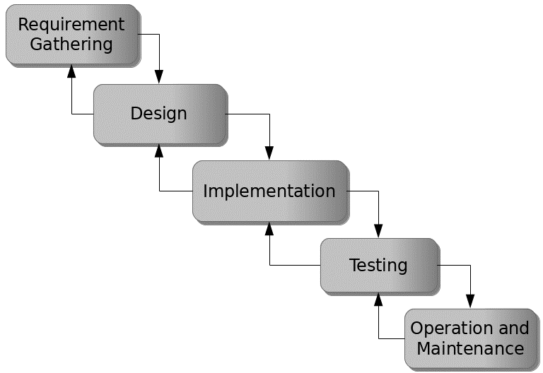

Figure 3.1: Waterfall model

## 3.5 Method of Data Collection

Data collection for the development of the Restaurant Reservation system were both primary and secondary sources. Primary sources include direct interactions with stakeholders, such as interviews and surveys, to gather requirements and feedback. Secondary sources encompass existing literature, research, and relevant documentation related to online tutoring platforms and system development.

## 3.6 System Design

System design for the Restaurant Reservation system involves defining the platform's architecture, modules, interfaces, and data structures to meet specified requirements. It entails the application of systems theory to product development, ensuring the alignment of design elements with the objectives and needs of the Restaurant Reservation system.

## 3.6.1 Algorithm Diagram

**Use case diagram**

A use case diagram shows the system and the various ways that they interact with the system.

## 3.6.1 Algorithm diagrams

**RESTAURANT RESERVATION SYSTEM**

Admin

User

Login

Registration

Make Reservation

Make Payment

Print Receipt

Add/Update Tables

View order

Print Report

Logout

Figure 3.2: Use Case Diagram

**Activity Diagram**

An activity diagram is a behavioral UML diagram that represents the flow of activities or actions in a system. For a Restaurant Reservation System with Payment, the activity diagram illustrates the sequential steps a user (customer) takes from logging in to completing a reservation, including how the system handles decisions and processes like checking table availability and payment.

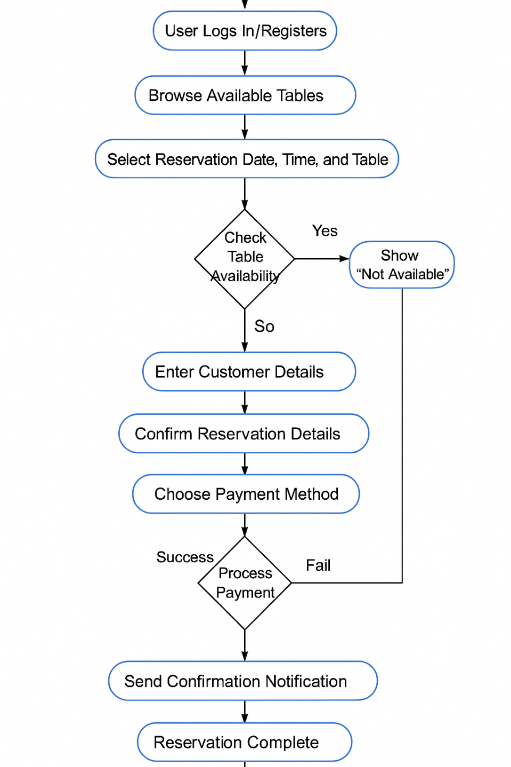

Yes

Is table available

No

Check Available Menu

Figure 3.3: Activity Diagram

**3.6.2 System Architecture**



Database MySQL

Apache Server

**RESTAURANT RESERVATION SYSTEM**

Figure 3.4: System Architecture

## 3.6.3 Database Tables/Queries Structures

The database is used to store all information that pertain the restaurant table reservation records. Below are the database table for the new system.

**Table 1: Booking Table**

Top of Form

| **Name** | **Type** | **Extra** |
| --- | --- | --- |
| id Primary | int(11) | AUTO_INCREMENT |
| booking_id Primary | int(11) |  |
| name | varchar(250) |  |
| email | varchar(250) |  |
| phone number | varchar(250) |  |
| Booking date | date |  |
| Booking time | time |  |
| No. of Adults | int(5) |  |
| No. of Children | int(5) |  |
| Booking status | int(5) |  |
| Date | timestamp |  |

**Table 2: Admin table**

**Top of Form**

| **Name** | **Type** | **Extra** |
| --- | --- | --- |
| **id Primary** | int(11 | AUTO_INCREMENT |
| **Name** | varchar(50) |  |
| **username Index** | varchar(50) |  |
| **email** | varchar(50) |  |
| **password** | varchar(50) |  |
| **contact** | bigint(11) |  |
| **User type** | varchar(50) |  |
| **Date** | timestamp |  |

**Table 3: Booking Status**

Top of Form

| **Name** | **Type** | **Extra** |
| --- | --- | --- |
| id Primary | int(11) | AUTO_INCREMENT |
| booking_id Index | varchar(250) |  |
| Table No. | varchar(250) |  |
| Booking status | varchar(250) |  |
| Remarks | varchar(250) |  |
| Date | timestamp |  |

**Table 4: Table**

Top of Form

| **Name** | **Type** | **Extra** |
| --- | --- | --- |
| id Primary | int(11) | AUTO_INCREMENT |
| Table No. | varchar(250) |  |
| Date | timestamp |  |

Bottom of Form

## 3.6.4 Database Entity Relationship Diagram

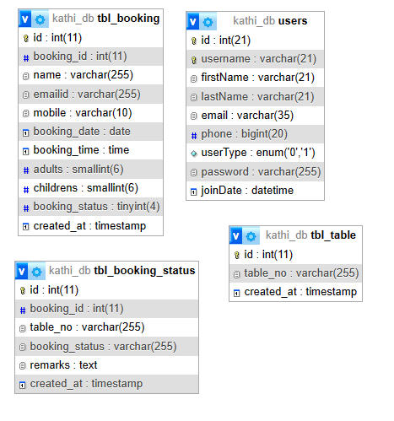

Figure 3.5: Database Entity Relationship Diagram

## 3.6.6 Input and Output Design

**RESERVATION FORM**

Customer Name

Email

**MAKE RESERVATION**

Phone Number

Booking date

Booking time

No. of Adults

No. of Children

Booking order placed? **Check Status**

Figure 3.6: Reservation Form

| Booking No. | Name | Booking Date | Booking Time | No. of Adults | No. of Children | Status |
| --- | --- | --- | --- | --- | --- | --- |
| 43543848 | MUSA ADAMU | 2024-07-10 | 02:50 pm | 2 | 0 | Booking Confirmed. |
| 22543348 | MUSA ADAMU | 2024-07-20 | 08:00 pm | 2 | 1 | Booking Confirmed. |

Figure 3.6: Reservation history

## 3.7 System Requirement Specification

## 3.7.1 Hardware Requirements

The software to be design needs the following hardware for an effective operation of the newly designed system.

1. A system running on intel, P(R) duo core with higher processor
2. The-Random Access Memory (RAM) should be at least 512MB.
3. At least 80-GB hard disk.
4. A monitor.

## 3.7.2 Software Requirements

The software requirements include:

1. A window 7 or higher version of operating system.
2. XAMP or WAMP for Database
3. PHP
4. MySQL
5. Browser

## 3.7.3 Personnel Requirement

Any computer literate who has a technical knowhow of internet surfing can use the system because it is user friendly.

# CHAPTER FOUR

# RESULTS AND DISCUSSION

## 4.1 Introduction

The new system is designed using PHP and MySQL programming language for easy records inserting and updating. The system was designed using HTML, PHP and MySQL as the database management programming languages for keeping records of the tutor finder system. The design also uses the Responsive type of web design where the content of the website fits exactly and the content is not loss when viewed on different device screen sizes and types. Also, the website is compatible when viewed on different browsers from device to device. PHP manage server-side logic, database interactions, and dynamic content generation. MySQL serve as the backend database, storing and retrieving all system data securely. JavaScript enhance the system's interactivity, perform client-side validation, and enable dynamic content updates. HTML/CSS structure the content, provide a clean and responsive design, and ensure compatibility across devices and browsers.

## 4.2 Results

**4.2.1 Registration interface**

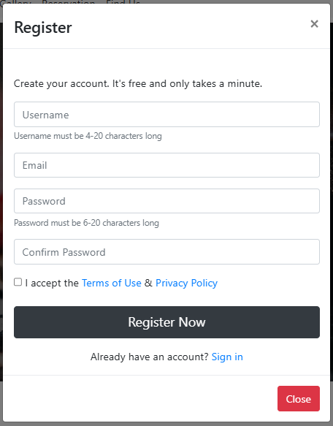

Figure 4.1: Registration interface

Figure 4.1 above shows where the customer can register or create an account in the system using some basic information like the first name, lastname, contact etc.

**4.2.2 Login Interface**

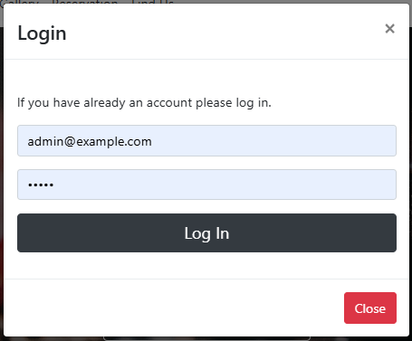

Figure 4.2: Login Interface

Figure 4.2 shows the login page of the system is where a user provides his or her login details (username and password) to gain access to the system.

## 4.2.3 Home page interface

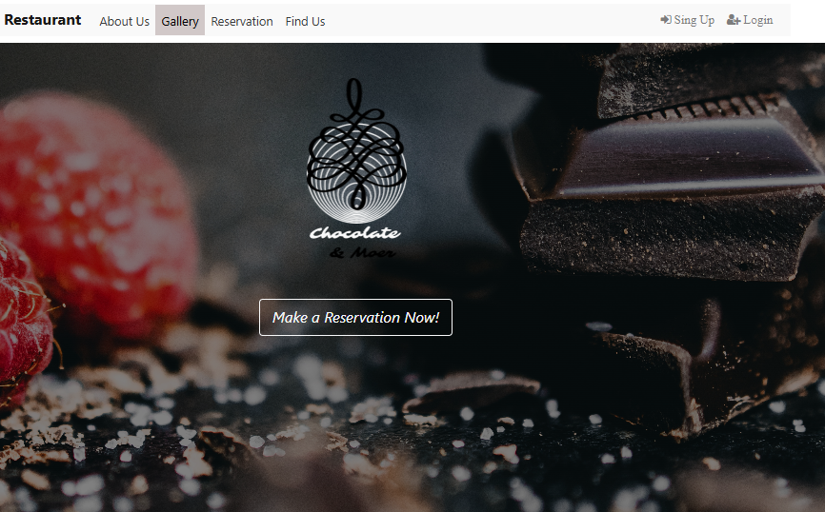

Figure 4.3: Home page interface

Figure 4.3 presents the Home Page Interface of the restaurant reservation System. This interface serves as the central landing page for users, offering quick access to essential system features.

**4.2.4 Make Reservation interface**

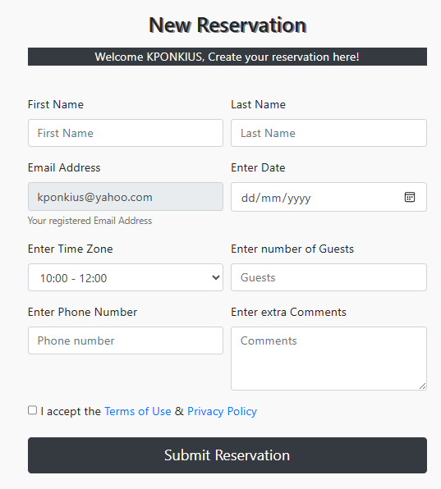

Figure 4.4: Make Reservation interface

Figure 4.4 presents the detailed view of a specific reservation. It includes comprehensive information such as the customer's name, contact details, date and time of the reservation, number of guests, table number, and any special requests.

4.2.5 Payment interface

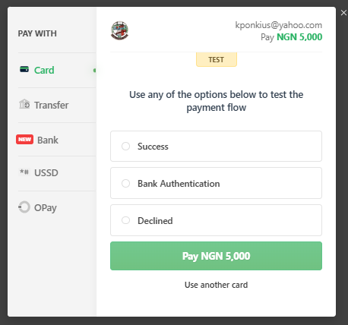

Figure 4.5: Payment interface

Figure 4.5 above shows the payment interface where a customer can make payment for his or her reservation for a particular date using the payment gateway.

**4.2.6 View Reservations**

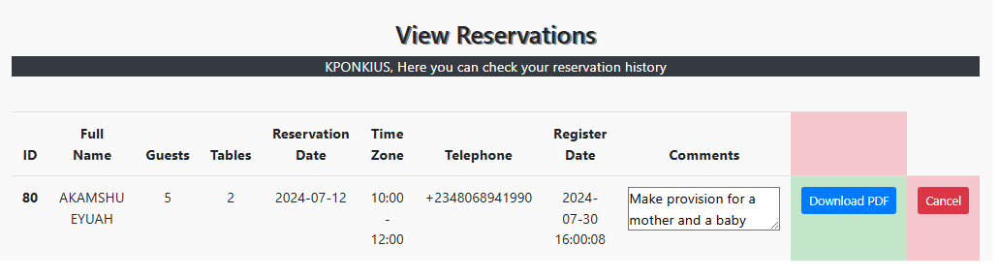

Figure 4.6: View Reservations

Figure 4.2 above represents the user reservations list of all the reservations that have been made on the system.

**4.2.7 Add Table Interface**

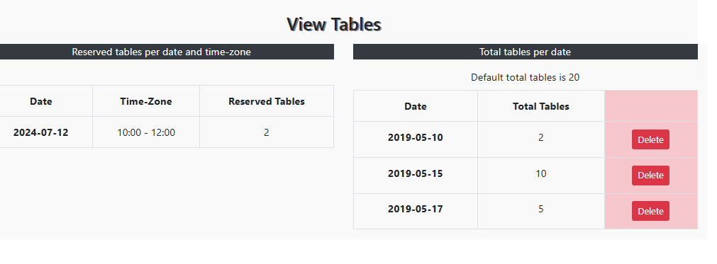

Figure 4.7: Add Table Interface

Figure 4.7: Add Table Interface, shows the interface used by restaurant staff to add new tables to the reservation system. Staff can input details such as table number, seating capacity, and location within the restaurant.

## 4.3 Discussion

The Registration Interface is where new users can create an account in the Restaurant Reservation System. It typically requires users to fill out a form with personal details such as name, email address, phone number, and a password. The interface might also include fields for additional information, such as preferred seating areas or special dietary requirements, which can be stored in the user's profile for future reservations. Once the form is completed and submitted, the system verifies the information and creates the user account, granting access to the booking system. User experience is enhanced by clear instructions, input validation, and confirmation messages to guide the registration process, as shown in Figure 4.1.

The Login Interface serves as the entry point for users, including customers and administrators, to access the Restaurant Reservation System. It is designed to ensure secure access by requiring users to enter their credentials, such as a username and password. The interface typically includes fields for these credentials and a button to submit the information. Additionally, it may offer options for password recovery and support for multi-factor authentication (MFA) to enhance security. Upon successful login, users are redirected to their respective dashboards, where they can manage reservations or administrative tasks, as shown in Figure 4.2.

The Make Reservation Interface is where customers can book tables at the restaurant. This interface allows users to select the date, time, and number of guests, and choose from available tables. It may also offer additional options, such as selecting a preferred seating area or adding special requests like dietary restrictions or celebrations. The interface typically includes a summary of the booking details before final confirmation. User-friendly design elements, such as a calendar view for selecting dates and real-time updates on table availability, enhance the overall booking experience, as shown in Figure 4.4.

The Payment Interface facilitates the secure processing of payments for reservations, deposits, or special services like event bookings. This interface usually provides multiple payment options, such as credit/debit cards, mobile wallets, or online banking. Users enter their payment details, and the system securely processes the transaction, often integrating with payment gateways to ensure data protection. The interface may also display a summary of charges, offer promotional codes, and provide a receipt or confirmation once the payment is successful. Ensuring a smooth and secure payment process is critical, as it directly impacts customer satisfaction and trust in the system, as shown in Figure 4.5.

The View Reservations Interface allows users, particularly customers and administrators, to see the details of current and past reservations. For customers, this interface provides a list of their bookings, including date, time, and table number, with options to modify or cancel reservations if needed. For administrators, the interface offers a comprehensive view of all reservations, including customer details and any special requests. Filters and search functionalities can be included to help users find specific reservations quickly, and the interface is often designed with a clean, easy-to-read layout to display all relevant information clearly, as shown in Figure 4.6.

The Add Table Interface is designed for administrators to manage the restaurant's seating arrangements by adding or modifying tables in the system. This interface allows the input of table details such as table number, seating capacity, location within the restaurant (e.g., indoor, outdoor, near a window), and availability status. The interface may also include options to categorize tables based on size or special features, like high chairs or wheelchair accessibility. Once a table is added or modified, the system updates the availability for customers making reservations, ensuring that the information reflects the current setup of the restaurant.

## 4.4 User manual

## 4.4.1 System Installation

The user manual is a clear and precise instruction on how a user can operate the propose system, without any stress and successful. The following steps required

1. Start or boot the computer form the hard disk
2. Double click on the folder that program is been stored in the desktop
3. Double click on the program and allow it to load gently
4. A security unit will display were the user will specify the user name and password the click on OK.
5. A welcome menu will be displayed where the user has options to select which operation to be performed.
6. To find information about player, select any name and search.
7. Click on exist on the welcome screen to exist from the program.

## 4.4.2 System Operational Guide

The following are the necessary steps to take in order to use the system efficiently and effectively.

1. Load the url of the system <https://localhost/reservation/> the welcome page will be displayed.
2. Click on the **Proceed** button to proceed to the main system.
3. If you created an account, provide your login details by entering your username and password.
4. Depending on the login details provided you will be automatically directed to the dashboard.
5. The various task that you can perform on the portal will be displayed on the sidebar of the dashboard.

# CHAPTER FIVE

# SUMMARY, CONCLUSION AND RECOMMENDATIONS

## 5.1 Summary

This chapter provides a comprehensive overview of NAZA Restaurant Reservation system project, highlighting key findings and outcomes. The system was designed to streamline the reservation process for both customers and restaurant staff, incorporating functionalities such as checking booking status, making reservations, adding tables, and viewing detailed booking information. The implementation of a user-friendly interface and robust backend infrastructure aimed to enhance the efficiency and user experience of managing Restaurant Reservations.

## 5.2 Conclusion

The Restaurant Reservation system effectively addresses the challenges faced by both customers and restaurant staff in managing reservations. By providing a centralized platform for making and managing bookings, the system reduces errors, minimizes overbooking, and improves overall operational efficiency. The implementation of various interfaces, such as the booking status check, reservation creation, table addition, and detailed booking views, ensures that all aspects of the reservation process are covered. The project has demonstrated the feasibility and benefits of using a digital solution to streamline Restaurant Reservations.

## 5.3 Recommendations

Based on the findings and outcomes of this project, the following recommendations are proposed:

1. Continuously improve the user interface to ensure ease of use and accessibility for all users, including those with disabilities.
2. Incorporate fast payment gateways to allow customers to pay for their reservations in advance, reducing no-shows and ensuring a smoother dining experience.
3. Develop a mobile application version of the system to provide greater convenience and accessibility for customers on the go.
4. Implement a feedback system where customers can rate their experience and provide suggestions for improvement, helping the restaurant to continuously improve its services.

# REFERENCES

Acheampong, S. (2018). *Design and implement an online restaurant reservation system* [Bachelor’s thesis, Nanjing University of Post and Telecommunication]. IJCSN.

Al-Khouri, A. M., & Abu-Jarour, S. (2020). Effective information management for government organizations. *International Journal of Public Administration, 43*(3), 225-240.

Chen, L., & Chen, Y. (2023). An intelligent reservation system for restaurants using machine learning algorithms. *Journal of Hospitality and Tourism Technology, 14*(2), 189-203.

Davis, M., Johnson, P., & Brown, S. (2023). The role of digital solutions in enhancing restaurant operations. *International Journal of Hospitality Management, 42*(3), 320-334.

Delen, D. (2021). Decision support systems and intelligent systems. *Prentice Hall, 10th Edition*.

Elmasri, R., & Navathe, S. B. (2019). Fundamentals of Database Systems. *Pearson, 7th Edition*.

Ghazal, R., Hassan, M., & Arif, M. (2020). NoSQL databases: New millennium database for big data analytics - Classification, characteristics and comparison. *Journal of Computer and System Sciences, 105*, 13-34.

Hishamudin, A. R., & Abdullah, S. N. (2022). Secure restaurant reservation platform: Password policy, role-based access control, and two-factor authentication. *International Journal of Secure Hospitality Systems, 5*(1), 87–101.

Khumalo, N. (2020). Information management systems in restaurant operations. *African Journal of Hospitality Management, 4*(1), 55–70.

Kim, J., & Kim, S. (2022). Contactless online reservation systems and their role during COVID‑19. *Journal of Restaurant Operations and Innovation, 10*(4), 203–218.

Kimes, S. E. (2016). Revenue management in restaurants: Applying yield management principles. *Cornell Hospitality Report, 16*(8), 1–12.

Latona, C. T. (2016). *Consumers’ acceptance of restaurant reservation systems* (Master’s thesis, Michigan State University).

Motahari-Nezhad, H. R., Stephenson, B., & Singhal, S. (2021). Outsourcing business to cloud computing services: Opportunities and challenges. *IEEE Internet Computing, 20*(4), 48-54.

Raharjo, Y. D., & Wahyurini, R. (2023). Lean startup and service design for “Eat‑Eat” restaurant reservation app. *Proceedings of the International Conference on Hospitality IT Innovation*, 91% of respondents cited queuing as a major issue.

Ramakrishnan, R., & Gehrke, J. (2020). Database Management Systems. *McGraw-Hill Education, 3rd Edition*.

Rizvi, S., Shamsi, J. A., & Raza, A. (2021). Efficient data retrieval using database management systems. *Journal of Information Science, 47*(3), 345-359.

Roberts, J., & Brown, T. (2023). Enhancing food ordering systems through advanced search functionality. *Journal of Foodservice Business Research, 20*(4), 455-470.

Roy, D., Spiliotopoulou, E., & de Vries, J. (2022). Restaurant analytics: Emerging practice and research opportunities. *Production and Operations Management, 31*(10), 3687–3709.

Samuel, O. (2018). *Design and implementation of an online restaurant reservation system* [Undergraduate thesis, Nanjing University of Post and Telecommunication].

Wang, D., & Nicolau, J. L. (2021). Evolution and impact of digital reservation systems in hospitality. *Journal of Hospitality & Tourism Technology, 12*(1), 1–17.

Wang, L., & Nicolau, J. L. (2021). Digital transformation in the restaurant industry: A review and future directions. *Tourism Management, 85*, 104-119.

Wang, Y., Liu, H., & Lee, M. (2021). Efficiency gains in restaurant operations via information management systems. *International Journal of Hospitality Information Management, 9*(2), 128–142

# APPENDIX A

Login Interface



View Reservations



Registration interface



Add Table Interface



Make Reservation interface



Payment interface



# APPENDIX B

**PROGRAM CODE**

<?php

require "header.php";

?>

<header class="header">

    <div class="row">

        <div class="col-md-12 text-center">

   <a class="logo"><img src="img/logo1.png" alt="logo"></a>

   </div>

        <div class="col-md-12 text-center">

            <button type="button" onclick="window.location.href='reservation.php'" class="btn btn-outline-light btn-lg"><em>Make a Reservation Now!</em></button>

        </div>

    </div>

</header>

<section id="aboutus">

 <div class="container">

   <h3 class="text-center"><br><br>Chocolate & Moer</h3>

   <div class="row">

<!--carousel-->

     <div class="col-sm"><br><br>

        <div id="carouselExampleIndicators" class="carousel slide" data-ride="carousel">

         <ol class="carousel-indicators">

           <li data-target="#carouselExampleIndicators" data-slide-to="0" class="active"></li>

           <li data-target="#carouselExampleIndicators" data-slide-to="1"></li>

           <li data-target="#carouselExampleIndicators" data-slide-to="2"></li>

         </ol>

        <div class="carousel-inner">

           <div class="carousel-item active">

             <img class="d-block w-100" src="img/3.jpeg" alt="First slide">

           </div>

           <div class="carousel-item">

           <img class="d-block w-100" src="img/4.jpeg" alt="Second slide">

           </div>

           <div class="carousel-item">

           <img class="d-block w-100" src="img/5.jpeg" alt="Third slide">

           </div>

        </div>

         <a class="carousel-control-prev" href="#carouselExampleIndicators" role="button" data-slide="prev">

           <span class="carousel-control-prev-icon" aria-hidden="true"></span>

           <span class="sr-only">Previous</span>

         </a>

         <a class="carousel-control-next" href="#carouselExampleIndicators" role="button" data-slide="next">

           <span class="carousel-control-next-icon" aria-hidden="true"></span>

           <span class="sr-only">Next</span>

         </a>

       </div><br><br>

     </div>

<!--end of carousel-->

     <div class="col-sm">

        <div class="arranging"><br><hr>

    <h4 class="text-center">Our Story</h4>

    <p><br>The restaurant MonkaS, first opened in 2004 in “Psiri”, one of the oldest districts of Athens in the historical center of the city. In 2010 , the restaurant was awarded its first Michelin star and has retained it since.<br><br>

    The same year, the restaurant relocated to the 6th floor of the Onassis Cultural Centre in Syngrou Avenue and was recently redesigned by award-winning architectural firm Divercity.In warmer months of the year the restaurant moves

    to the 7th floor of the building, offering a unique outdoor setting with panoramic view of the Acropolis, Lycebettus hill and the city skyline.<br><br><br></p><hr>

    </div>

     </div>

    </div><br>

  </div>

</section>

<!--end of about us section-->

<div class="header2">

</div>

<!----gallery -->

<div class id="gallery"><br>

    <div class="container">

    <h3 class="text-center"><br>Gallery<br><br></h3>

        <div class="d-flex flex-row flex-wrap justify-content-center">

           <div class="d-flex flex-column">

              <img src="img/1.jpg" class="img-fluid">

              <img src="img/2.png" class="img-fluid">

           </div>

           <div class="d-flex flex-column">

              <img src="img/3.jpeg" class="img-fluid">

              <img src="img/4.jpeg" class="img-fluid">

           </div>

           <div class="d-flex flex-column">

               <img src="img/5.jpeg" class="img-fluid">

               <img src="img/6.jpeg" class="img-fluid">

           </div>

           <div class="d-flex flex-column">

               <img src="img/7.jpeg" class="img-fluid">

               <img src="img/8.jpeg" class="img-fluid">

           </div>

        </div>

    </div>

</div><br><br>

<!----end of gallery -->

<div class="container" id="reservation">

    <h3 class="text-center"><br><br>Reservation<br><br></h3>

    <img  src="img/16.jpg" class="img-fluid rounded">

    <button type="button" onclick="window.location.href='reservation.php'" class="btn btn-outline-dark btn-block btn-lg">Make a reservation Now!</button>

</div><br><br>

<div class="header2">

</div>

<!-- main page map section-->

<section class="map" id="footer">

    <div class="container">

    <h3 class="text-center"><br><br>Find us!</h3><br>

        <iframe src="https://www.google.com/maps/embed?pb=!1m21!1m12!1m3!1d3150.1829966583578!2d23.75232003459512!3d37.85600838634192!2m3!1f0!2f0!3f0!3m2!1i1024!2i768!4f13.1!4m6!3e0!4m3!3m2!1d37.8566691!2d23.752137599999998!4m0!5e0!3m2!1sel!2sgr!4v1524459240043" style= "width:100%;  height:250px; border:0;" allowfullscreen></iframe>

        <div class="row staff">

            <div class="col">

            <h4><strong>Opening Hours</strong></h4>

                <div class="signup-form">

                    <form action="#footer" method="post">

                        <div class="form-group">

                            <label>Enter Date</label>

                            <input type="date" class="form-control" name="date" placeholder="Date" required="required">

                        </div>

                        <div class="form-group">

                            <button type="submit" name="check_schedule" class="btn btn-dark btn-block">Check Open Time</button>

                        </div>

                    </form>

<?php

if(isset($_POST['check_schedule'])){

require 'includes/dbh.inc.php';

$date= $_POST['date'];

    $sql = "SELECT * FROM schedule WHERE date = '$date'";

    $result = $conn->query($sql);

    if ($result->num_rows == 1) {

        while($row = $result->fetch_assoc()) {

            echo"

                <table class='table table-sm table-striped table-dark text-center'>

                   <thead>

                    <tr>

                    <th scope='col'>Date</th>

                    <th scope='col'>Open Time</th>

                    <th scope='col'>Close Time</th>

                    </tr>

                   </thead>

                   <tbody>

                    <tr>

                    <th scope='row'><em>". $date . "</em></th>

                    <td>".$row['open_time']."</td>

                    <td>".$row['close_time']."</td>

                    </tr>

                   </tbody>

                </table>";

                }

            }

        else{

         echo"

                <table class='table table-striped table-dark text-center'>

                   <thead>

                    <tr>

                    <th scope='col'>Date</th>

                    <th scope='col'>Open Time</th>

                    <th scope='col'>Close Time</th>

                    </tr>

                   </thead>

                   <tbody>

                    <tr>

                    <th scope='row'><em>". $date . "</em></th>

                    <td>12:00</td>

                    <td>00:00</td>

                    </tr>

                   </tbody>

                </table>";

            }

   //close connection

   mysqli_close($conn);

}

?>

            <h4 class="text-right"><strong>Visit Us</strong></h4>

            <p class="text-right">Chocolate & Moer<br><i class="fa fa-map-marker"></i>&nbsp; Leof. Posidonos 109, <br>Glyfada <br><br>email: info@domain.com<br>phone: +00 (123) 456 7890</p>

            </div>

    </div>

    </div>

</section>

<!--end of main page map section-->